**CITEM Environmental Sustainability Program**

**IBC Sustainability Laboratory**

**Programs**

1. **Circular Economy**

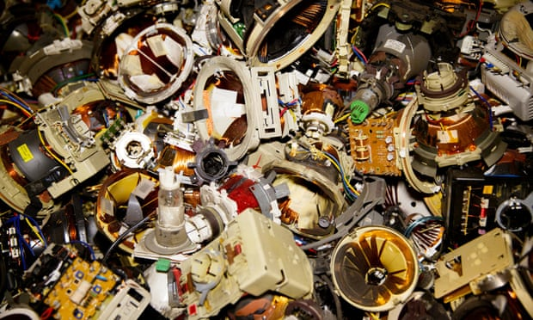 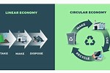

1. **Waste to Wealth Training & Consultancy**

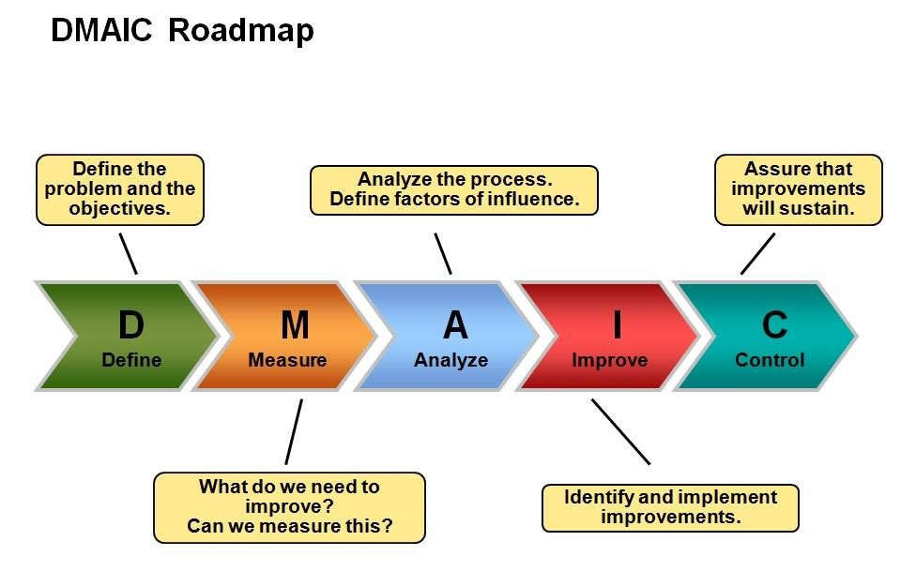

1. **Food Waste Reduction**

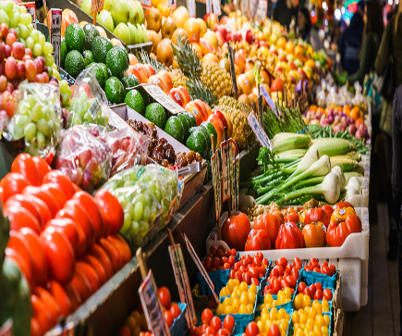 [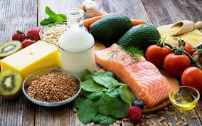](https://www.google.com/imgres?imgurl=https%3A%2F%2Feruza.com%2Fwp-content%2Fuploads%2F2017%2F01%2Ffoodindustrystatistics-1080x675.jpg&imgrefurl=https%3A%2F%2Feruza.com%2Ffood-industry-statistics-metrics%2F&docid=auRmqPxlH3fuXM&tbnid=M7jxgzs0ReW96M%3A&vet=1&w=1080&h=675&bih=607&biw=1067&ved=2ahUKEwi3pfzmhf7lAhWB_J4KHWW2BngQxiAoCnoECAEQKw&iact=c&ictx=1)

1. **E- Waste Recycling**

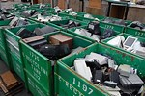 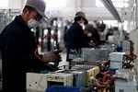 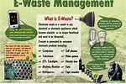

1. **Environmental Sustainability & Climate Change Research**

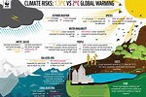 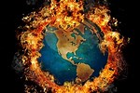 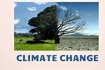

1. **Energy Conservation & Renewability**

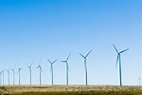 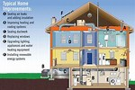 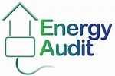

1. **United Nations Sustainable Development Goals**

